**Chromatic Aberration(色差)**

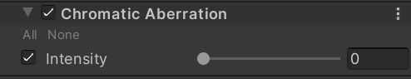

**Intensity**

Amount of tangential distortion.

#if _CHROMATIC_ABERRATION{

float2 coords = 2.0 * uv - 1.0;

float2 end = uv - coords * dot(coords, coords) * ChromaAmount;

float2 delta = (end - uv) / 3.0;

half r = SAMPLE_TEXTURE2D_X(

_SourceTex,sampler_LinearClamp,uvDistorted).x;

half g = SAMPLE_TEXTURE2D_X(

_SourceTex, sampler_LinearClamp, DistortUV(delta + uv)).y;

half b = SAMPLE_TEXTURE2D_X(

_SourceTex, sampler_LinearClamp, DistortUV(delta * 2.0 + uv)).z;

color = half3(r, g, b);

}